SECTION B

GENERAL DESCRIPTION

GENERAL DESCRIPTION

1. The 16RP200M Valenta engine, is a 16 cylinder compression ignition engine of the four stroke, direct injection, turbocharged and charge air cooled type. The cylinders are arranged in two banks of eight at an included angle of 60°.

Crankcase

1. The crankcase is a one-piece, fabricated construction composed mainly of welded steel castings. The lower portion is divided into compartments by transverse webs which are formed to carry the main bearings. The deep, side fitting bearing caps which carry the lower half main bearing shells, are retained in position by studs and nuts, and by four capscrews at each bearing cap position. The capscrews pass through the crankcase and screw into the bearing caps, thereby stiffening the crankcase laterally at its lower end. The main bearing caps are stiffened longitudinally by a channel tie bar secured to the underside of the caps by hollow dowels and setscrews. The crankcase is stiffened at its upper end by lateral tie bars inserted into the top of the cam trough at each bearing station and secured by bolts.
2. The crankcase is fitted with chromium plated wet type cylinder liners. Each liner is sealed to the crankcase at its upper end by a copper-plated steel joint ring and an 'O' ring beneath the liner flange, and at its lower end by three 'O' rings carried in grooves machined on the outside of the liner. The walls of the crankcase form part of the water jacket.
3. Openings in the lower portion of the crankcase provide access to the large-end bearings. The openings are covered by detachable doors secured by setscrews and sealed by flat joints. Of the sixteen doors, nine are plain, four are fitted with crankcase explosion relief valves and flame shields, one is fitted with an angled boss for the lubricating oil dipstick mounting, and two are fitted with a boss for the lubricating oil drain from the fuel pump camboxes.
4. The lubricating oil sump is of welded construction and is secured to the underside of the crankcase by setbolts and domed washers.

Crankshaft and Main Bearings

1. The crankshaft is a fully machined, hardened steel forging. Drillings in the crankpins and journals, connecting with reservoirs formed in the shaft, provide for pressure lubrication of the large-end bearings. Certain of the crankwebs are fitted with balance weights which are secured in position by capscrews and located by dowels.
2. A gearwheel, bolted to the crankshaft at the drive-end of the engine, provides the drive to the engine camshaft, fuel pump camshafts, coolant pump, lubricating oil pump and governor etc, through a train of gears.
3. Two viscous-type torsional vibration dampers, bolted to a flange at the free-end of the crankshaft, are totally enclosed by the free-end cover. Plugs are provided in the dampers to obtain samples of the viscous fluid for laboratory analysis to determine damper life.
4. The main bearings are steel-backed, tin-aluminium lined shells and are lubricated directly from the main oil gallery. Each bearing shell is prevented from turning by a locating key recessed into the face of the main bearing cap and positioned by one of the main bearing cap studs, the key engaging with a slot in the cap half shell. The bearing shell halves are positioned relative to each other by locating dowels fitted to the 'horns' of the cap half shell.
5. Crankshaft end thrust is taken by steel-backed, copper-lead faced thrust pads fitted to both sides of No. 10 main bearing station. The steel backing of the cap-half thrust pad is larger in diameter than the pad fitted to the crankcase, and therefore, when fitted, locates against the crankcase to prevent rotation.

Connecting Rods and Large-end Bearings

1. The connecting rods are alloy steel stampings, fully machined for weight and balance. Two types of connecting rod are fitted; those for 'B' bank being forked in order that 'A' bank rods may be accommodated centrally. A two-piece bearing block, dowel-located to the flat palm of the forked connecting rod, is secured by four special bolts and nuts. The mating faces of the bearing block halves are serrated and dowelled to ensure precise location.
2. The centre or blade connecting rod pivots on the nitrided outer diameter of the bearing block, two special setbolts securing the bearing cap in position. The joint face of the centre rod and cap is angled to allow withdrawal through the cylinder bore, and is serrated for precise location.
3. The forked rod large-end bearings are steel-backed tin-aluminium alloy lined shells, whilst the centre rod bearings are steel-backed copper-lead lined shells. The bearing surface of each shell is lead-tin flashed to assist running-in and to prolong the service life of the bearing.

Pistons

1. The pistons are cast in aluminium alloy with specially shaped crowns to form the combustion space. Each piston carries three compression rings and one oil control ring, all fitted above the gudgeon pin. The top compression ring groove is machined in an austenitic iron insert cast into the piston.
2. The gudgeon pins are fully floating and are retained in the piston by wire-type circlips.

Camshaft and Cam Followers

1. The camshaft, mounted in the vee formed by the cylinder banks, runs in unbushed, pressure-lubricated bearings.
2. With the exception of the free-end camshaft journal, which runs in a combined bearing housing and blanking cover inserted from the outside of the crankcase, all the journals run in one-piece tunnel-type bearing housings bolted into position in the camtrough.
3. The camshaft is flanged to carry the drive gear which is secured by setbolts and tabwashers. End thrust is controlled by a thrust collar mounted in a recess formed between the drive gear and the camshaft. The thrust collar is secured to the governor drive mounting spindle and is prevented from rotating by locating tongues on the spindle.

LIMITED RIGHTS LEGEND

4

USE, DUPLICATION OR DISCLOSURE OF THIS INFORMATION WHICH IS THE PROPERTY

OF GEC ALSTHOM DIESELS LIMITED BY THE U.S. GOVERNMENT OR BOLLINGER IS SUBJECT TO THE RESTRICTIONS SET FORTH IN DOD FAR SUPP 252.227-7013 (a) 15.

1. The cam followers are of the direct acting roller type and transmit motion to the valve gear via hollow push rods. The follower rollers are held in contact with the cams by return springs which also retain the hardened push rod cups in the follower bodies. The cam followers, operating in housings bolted into the camtrough above the camshaft, are prevented from rotating by locating pegs which engage with slots in the cam follower bodies.
2. The drive-end cam follower housing also incorporates the drive-end camshaft bearing and the coolant pump drive.

Cylinder Heads and Valve Gear

1. The cast iron cylinder heads are single units and completely interchangeable. Each head is secured at eight points, two studs at the front and two at the rear passing through the casting, whilst two semi-circular grooves in each side face accommodate the remaining studs which also secure the adjacent heads by means of bridge blocks.
2. The heads are positioned by sleeve-type dowels fitted to one of the front and one of the rear cylinder head studs, whilst a copper-plated steel joint ring fitted between the liner flange and head forms the gas seal.
3. Two inlet and two exhaust valves per head operating in pressed-in guides, are actuated by rocker levers through bridge pieces; the bridge pieces located by, and operating against, guides secured to the cylinder head.
4. The valves seat on hardened inserts shrunk into the cylinder head and are fitted with helical springs secured to the valves by spring carriers and split collets. Circlips are fitted in the spring carriers above the split collets to prevent possible displacement.
5. The fuel injector, positioned centrally in the cylinder head and secured by a clamp and setbolt, is mounted in a removable housing. The lower end of the housing screws into the bottom deck of the head and is sealed by an angled face, whilst the upper end is sealed to the top deck of the head by two 'O' rings.
6. A feature of the injector/injector housing is the fuel drain arrangement. Back leak- off from the injector is bled to an annulus machined in the bore of the injector housing then through a drilling in the housing wall to a second annulus machined in the outside of the housing. From this point, drillings in the cylinder head and crankcase convey the fuel to a drain rail mounted on the outside of the crankcase. 'O' rings fitted to the fuel injector above the internal annulus and to the injector housing above and below the external annulus prevent fuel leakage to and contamination of the lubricating oil and engine coolant.
7. Transfer ferrules and joints are provided between the crankcase and cylinder heads for the coolant, fuel drain and push rod apertures.
8. Lubricating oil draining from the valve rocker gear is led to the outboard side of the cylinder head where it is drained, via a system of spring-loaded ferrules between the heads, to a drain pipe at the free-end of the engine or to a drain passage cast into the bridge block support at the drive end of the engine.

Fuel System

1. The fuel system is of the full flow type and is pressurised by an engine driven fuel feed pump mounted at the free-end of the 'B' bank fuel pump cambox.
2. Fuel is drawn from the service tank by the engine driven feed pump and supplied to the fuel injection pumps via a filter and a two stage fuel reservoir, where any entrapped air and a small quantity of fuel is returned to the service tank via a permanent bleed. Pressure in the system is controlled by relief valves in the feed pump and reservoir, fuel in excess of requirements being returned back to the service tank.
3. Each fuel injector is served by a cam-operated constant stroke fuel injection pump, one per cylinder, positioned opposite each cylinder. The pumps are mounted on the fuel pump camboxes secured to the outboard side of each cylinder bank. They are operated by camshafts which are driven from the drive-end gear train.

Engine Governor and Controls

1. Engine speed/load is controlled by a centrifugal, electronic type governor, mounted at the drive-end of the engine over the gear train compartment, and driven from the drive-end gear train by a vertical drive shaft and a speed reducing gearbox.
2. The governor controls the fuel injection pumps via levers and rods across the drive- end of the engine to longitudinal control shafts, bracket-mounted the length of the fuel pump camboxes. Levers mounted on the control shafts opposite each pump provide a positive movement towards 'FULL FUEL' and a spring return towards 'NO FUEL', ensuring that should one fuel rack stick, the remaining racks can be returned to 'NO FUEL' to shut down the engine.
3. Should the engine speed exceed a preset figure, the fuel injection pump control racks are returned to 'NO FUEL' position by a shutdown unit mounted at the drive- end of 'A' bank fuel pump cambox. The shutdown unit, which is hydraulically actuated by an overspeed trip unit mounted on the drive-end of the crankcase, is operated simultaneously with a flap valve in the air supply piping between the turbocharger and charge air/heater cooler.

Lubrication System

1. Oil is drawn from the sump by two gear-type pumps and supplied via internal piping to a thermostat mounted in the free-end cover.
2. The thermostat controls the temperature of the oil circulating through the engine. When the oil is cold, the thermostat is closed and all oil flows to a gallery in the top of the free-end cover before leaving for filtration. As the temperature of the oil rises, the thermostat partially opens to permit a portion of the oil to flow through the oil cooler mounted on the free-end cover. After cooling, the oil returns to the gallery in the top of the cover to mix with the uncooled oil flowing from the thermostat.
3. A relief valve, mounted on the free-end cover, controls the pressure of the oil in the system, excess oil being relieved into the free-end cover, cooling the viscous dampers.
4. After cooling, the oil is supplied to the lubricating oil filters before entering the engine main oil gallery.
5. Drillings in the crankcase convey oil from the main gallery to the main bearings from where drillings through the crankshaft supply oil to the connecting rod large- end bearings. Oilways along the length of the connecting rods supply oil for small- end bearing lubrication and for piston cooling.

LIMITED RIGHTS LEGEND

6

USE, DUPLICATION OR DISCLOSURE OF THIS INFORMATION WHICH IS THE PROPERTY

OF GEC ALSTHOM DIESELS LIMITED BY THE U.S. GOVERNMENT OR BOLLINGER IS SUBJECT TO THE RESTRICTIONS SET FORTH IN DOD FAR SUPP 252.227-7013 (a) 15.

1. The drive-end idler gear spindles and bearings, and the tachometer generator drive are supplied with oil from the drive-end main bearing via drillings in the crankcase end wall.
2. A vertical drilling from the main oil gallery at the free-end of the engine supplies oil to the camshaft free-end bearing and then, via an adaptor, to the free-end cam follower housing and coolant circulating pump. T shaped interconnecting pipes transfer oil between the cam follower housings and also supply the camshaft journals. From the centre cam follower housings oil is also supplied to the intermediate bearing for the coolant pump drive cardan shaft. The drive-end cam follower housing is drilled to supply oil to the coolant pump drive and the drive-end camshaft bearing. Drillings through the camshaft drive-end journal and the camshaft thrust collar retaining bolt convey oil to the thrust collar and governor drive.
3. Lateral drillings in the cam follower housings convey oil to the follower bodies and roller bearings, then via drillings in the bodies, push rod cups, tubular push rods, and rocker levers to the rocker lever bearings and valve operating gear. Oil draining from the rocker gear flows to the front of the head and then via transfer ferrules between the heads to the free-end and drive-end of the engine, from where it is returned to the sump through drain piping or cast oilways.
4. Oil for the fuel pump camshafts is supplied from each side of the engine free-end cover to the end covers of the fuel pump camboxes, and then via transfer shafts to a drilling through the centre of the camshafts. Radial drillings at each journal convey oil to the bearing surfaces.
5. Oil for fuel injection pump plunger sealing and tappet roller lubrication is also taken from the engine free-end cover, the oil supply pipes running the full length of each cambox. Tappings opposite each pump supply oil to drillings in the cambox. Whilst the feed to the tappets is direct, the supply for plunger sealing is taken via transfer ferrules fitted with non-return valves, preventing any possible back leakage of fuel to the lubricating oil system.
6. The turbocharger bearings are lubricated from the engine circuit, the supply being piped from the free-end cover via a restrictor to control the pressure. Oil draining from the turbocharger is returned to the camtrough cover.
7. Oil for the operation of the overspeed trip mechanism is taken from the turbocharger supply.

Cooling Systems

1. The cooling system is divided into two parts, one using treated water (coolant), and the other sea/raw water.
2. Coolant is circulated through the engine by a centrifugal pump mounted at the free- end of the engine and driven from the drive-end gear train by a two-piece cardan shaft housed within the engine cambox.
3. When the engine commences to operate, the pump delivers coolant to inlet manifolds incorporated in the fuel pump camboxes on either side of the engine crankcase. From the inlet manifolds the coolant enters the cylinder jackets and after circulating round the cylinder liners, passes to the cylinder heads via transfer ferrules fitted between the crankcase and the heads. Within the heads the coolant circulates round the injector housings and valve seats before flowing out to the exhaust manifolds.

LIMITED RIGHTS LEGEND

USE, DUPLICATION OR DISCLOSURE OF THIS INFORMATION WHICH IS THE PROPERTY n

OF GEC ALSTHOM DIESELS LIMITED BY THE U.S. GOVERNMENT OR BOLLINGER IS '

SUBJECT TO THE RESTRICTIONS SET FORTH IN DOD FAR SUPP 252.227-7013 (a) 15.

1. Coolant is supplied to the turbocharger from the exhaust manifolds via transfer ports and piping. After circulating through the turbocharger, the coolant is conveyed to a pipe where it mixes with the coolant from the exhaust manifolds before entering the thermostat.
2. The thermostat is incorporated in the system to enable the coolant to reach its optimum operating temperature rapidly. As the temperature of the coolant is lower than the minimum setting of the thermostat when the engine first commences to operate, the thermostat outlet to the heat exchanger is closed and all coolant flows from the thermostat to the suction side of the coolant pump via a by-pass pipe. As the coolant temperature rises above the minimum setting of the thermostat, the thermal elements in the thermostat commence to operate to permit a certain amount of coolant to flow to the heat exchanger. When the coolant attains its operating temperature, flow through the by-pass pipe to the pump ceases and all coolant then passes to the heat exchanger for cooling.
3. Sea water is circulated through the charge air/heater coolers, oil coolers and heat exchanger by an independent self-priming pump side mounted at the free-end of the engine, belt-driven from the crankshaft.

Air and Exhaust System

1. Air under pressure is supplied to the cylinders by a turbocharger via air inlet piping and a charge air/heater cooler.
2. The turbocharger comprises a centrifugal air compressor and a single-stage axial- flow turbine directly coupled by a common shaft running in plain bearings. The turbocharger, which is mechanically independent of the engine, is lubricated from the engine supply.
3. The turbocharger is driven by exhaust gases conveyed from the cylinder heads by the exhaust manifolds. The connections between the cylinder heads and the exhaust manifolds are bellows type joints expanded into position, whilst the manifolds are directly connected to the turbocharger and sealed by joint rings.

Engine Starting

1. The engine is started by 24-volt axial type electric starter motors cradle mounted in brackets bolted to each side of the crankcase at the drive-end of the engine. The motors engage with a starter ring bolted to the engine-half flywheel.
2. Pre-heat equipment is fitted to maintain the engine coolant at a set temperature avoiding a prolonged warming-up period and allowing the engine to be placed on load immediately after starting.
3. If the pre-heat equipment has not been used, Start Pilot cold starting equipment is provided to assist engine starting under low ambient temperature conditions.

Key To Numbers

1. Turbocharger
2. Cylinder liner
3. Cylinder head
4. Fuel injector
5. Air shutdown valve
6. Charge air heater/cooler
7. Air inlet manifold
8. Fuel injection pump covers
9. Fuel injection pump
10. Free-end cover
11. Crankcase door
12. Fuel injection pump control gear
13. Lubricating oil suction strainer
14. Lubricating oil pumps
15. Lubricating oil sump
16. Drive gear, fuel injection pump camshaft

17 Crankshaft

1. Governor drive
2. Drive gear, engine camshaft
3. Drive gear, coolant circulating pump
4. Engine lifting eyebolt 22 Crankcase breather
5. Engine governor
6. Exhaust manifold

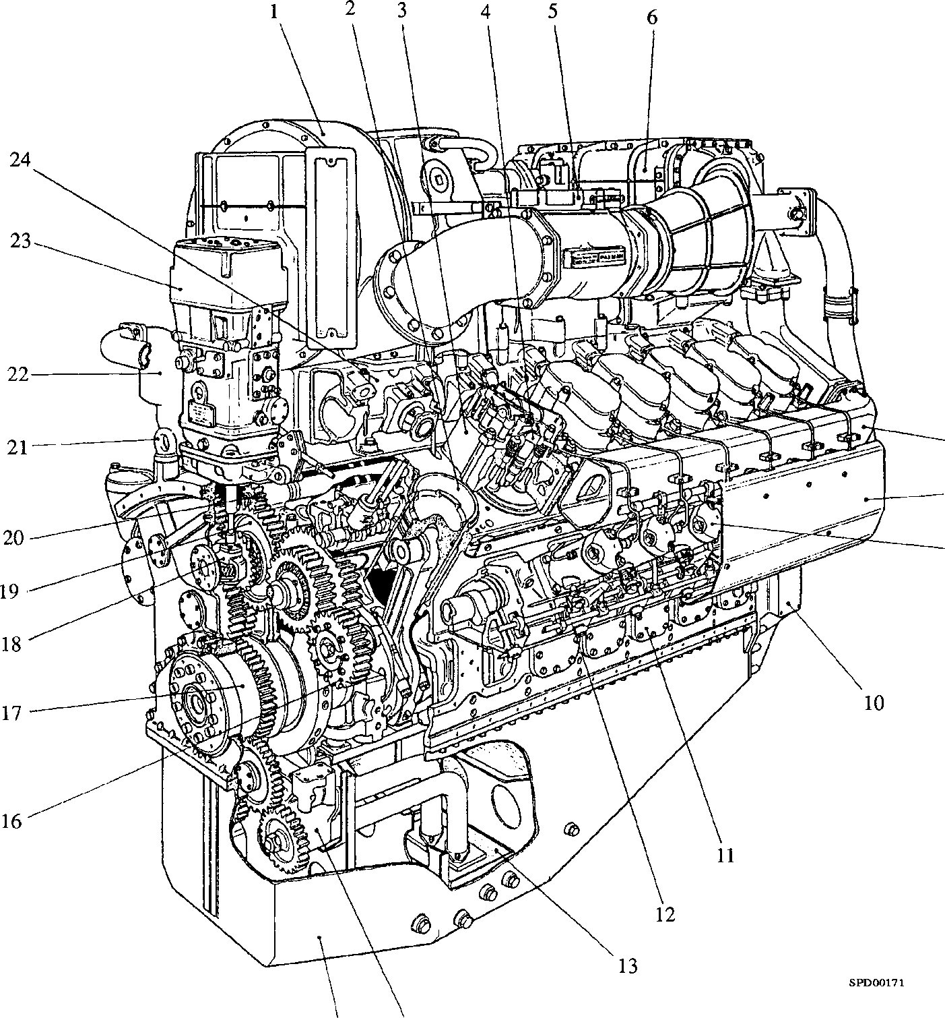

15 14

Fig B1 Cutaway view of engine